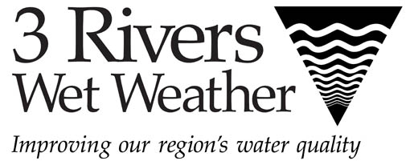

Sponsorship Opportunities

23rd Annual 3 Rivers Wet Weather Sewer Conference

November 2-3, 2022  Monroeville Convention Center

3 Rivers Wet Weather is once again offering several popular sponsorship opportunities to exhibitors for its 23rd Annual Sewer Conference. Each sponsorship opportunity will be determined on a first-come, first-served basis, so if you are interested in being a sponsor, please complete the form and return it to 3RWW as soon as possible. You will receive confirmation of your sponsorship within three business days.

All sponsors receive:
- Special signage at the conference
- Recognition during the conference session announcements
- A company logo in the conference booklet (if sponsorship is obtained before the booklet printing).
- The opportunity to submit a company marketing flier or brochure to be included in the conference materials provided to each attendee.

All specialty items will include the conference name and 3RWW logo along with the sponsor’s logo (all printed in one color),and will be produced in an anticipated quantity of 550 to be distributed to all conference attendees. Payment will be required up front in order to reserve a sponsorship. If you are interested in a sponsorship, but do not see one that exactly fits your needs/preferences, please contact Tracy Schubert (tschubert@3rww.org). We may be able to customize a sponsorship option for you.

Three ways to pay:
1. Include sponsorship cost on your exhibitor registration form and make one payment.
(After your sponsorship is confirmed.)
2. Make separate check for sponsorship payable to 3RWW.
3. Pay by credit card (3% transaction fee applies), via PayPal. (3RWW will send a PayPal invoice to you. You do not need a PayPal account to process your credit card payment.)
If you would like to become a sponsor, please complete the information below and send via e-mail to tschubert@3rww.org. For questions or if you would like to sponsor an item not shown, please contact
Tracy Schubert. Please note that 3RWW will be requesting a one-color (preferably black) logo in a high-resolution format (An eps file is recommended.) for printing in the conference brochure/on signage as well as for printing on the sponsored promotional item.

See page 2 for details on the sponsorship opportunities and the sponsorship form.

Company Name: |  |  |  |  | Contact Person:
E-mail: |  |  |  |  | Phone:
Sponsorship opportunity in which you are interested: (PLEASE NOTE: If it is a food/beverage sponsorship, please indicate the meal and date you would like to sponsor.)
1st choice: |  |  |  | 2nd choice:
Payment:  Included with exhibitor registration payment  Check  Credit Card via PayPal

Food/Beverage Breaks:
 |  | Partial Sponsorship | Full Exclusive Sponsorship
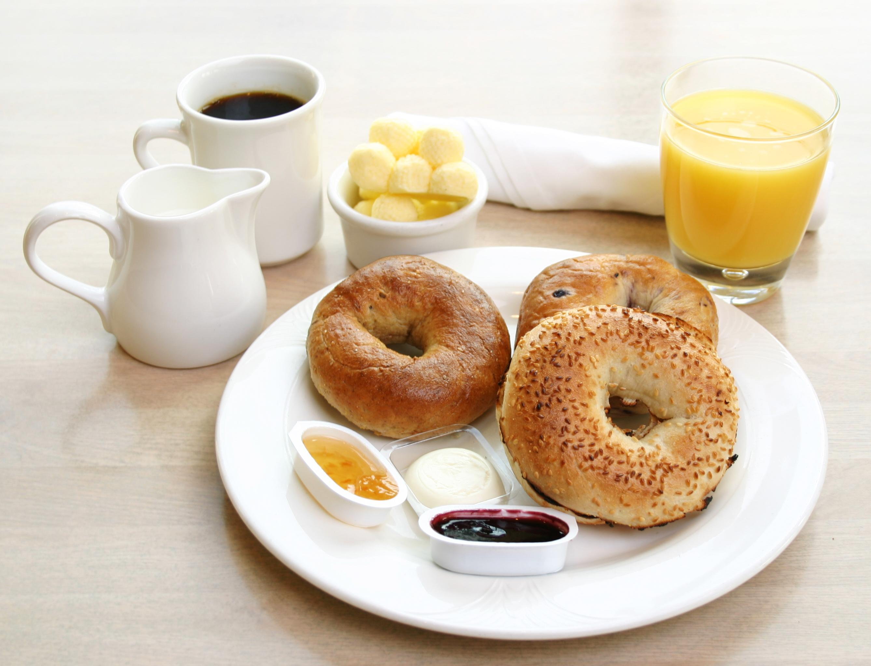 | ❒ Continental Breakfast on Wednesday, Nov. 2  OR Thursday, Nov. 3  OR Thursday, Oct. 18: | $600 | $3,000
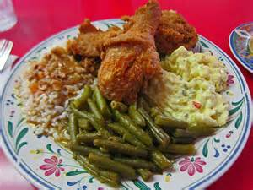 | ❒ Lunch on Wednesday, Nov. 2  OR Thursday, Nov. 3 | $600 | $4,000
 | ❒ Afternoon Refreshment Break on Wed., Nov. 3 | $600 | $3,000
Sponsors of the meal and refreshment breaks will be featured on prominent signage and will also be acknowledged by the emcee throughout the conference.

Specialty Items:
Please note: Pictures are for reference only. Final product may vary.

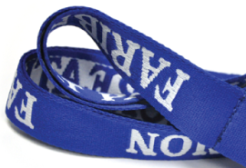 | ❒ Name tag lanyards: | $1,000
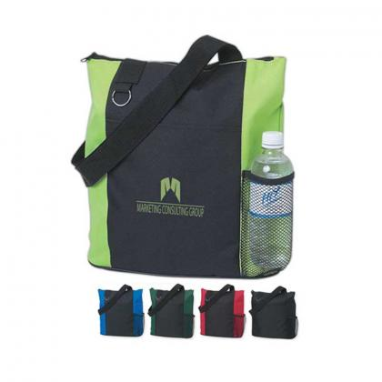 | ❒ Conference tote bag | $3,700
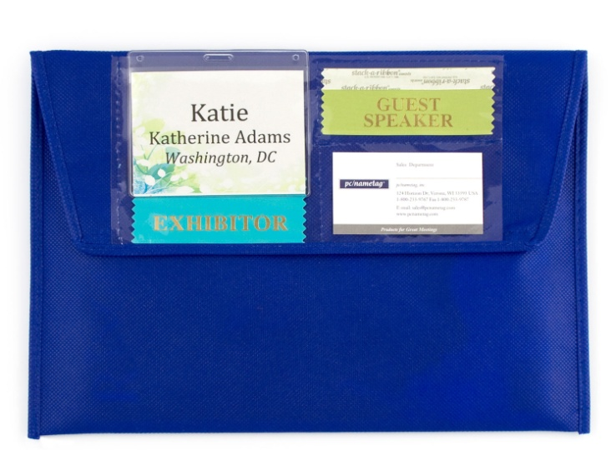 | ❒ Conference materials envelope: | $1,600

