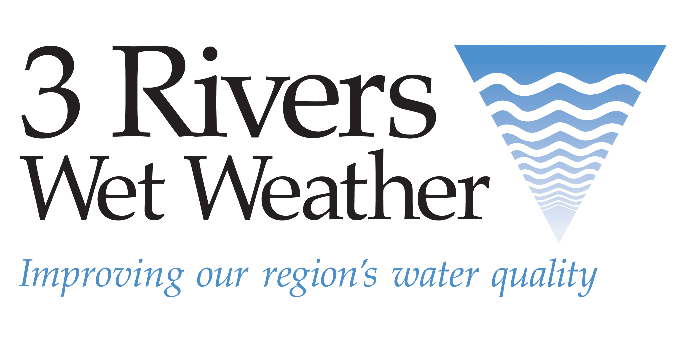

Advertising & Sponsorship Opportunities

24th Annual 3 Rivers Wet Weather Sewer Conference

November 1-2, 2023  Monroeville Convention Center

NEW this year:
Advertising opportunities

3 Rivers Wet Weather is expanding its marketing opportunities for exhibitors in 2023 by offering advertising in our widely distributed conference booklet: Electronic distribution to more than 1,500 potential customers and more than 550 printed booklets distributed to conference attendees. The booklet will also reach countless 3RWW website users online. Advertisers will also receive their logo printed on a poster on display at the conference. See below for ad sizes, pricing, and ad submission requirements.

All advertisers receive:
- Full-COLOR ad (See size options below)
- Logo included on a poster displayed at the conference

Ad Sizes, Prices & Specs
- Full page (8”w X 10.5”h): $500
- Half page (8”w X 5.25”h): $350
- Quarter page (4”w X 5.25”h): $250
- Business card: $150
- Inside back cover (full page): $750
- Back cover (full page): $1,000

Please complete the form below and send a high-resolution pdf or eps file of the ad in the correct size to tschubert@3rww.org. All ads will be printed in full color. If a black and white ad is submitted, it will be printed in black and white.

Continuing this year:
Sponsorship opportunities

We are also continuing to offer our popular sponsorship opportunities to exhibitors, including specialty conference items and meal/refreshment breaks. See details below for opportunities and pricing. You will receive confirmation of your sponsorship within three
business days of receiving your completed form.

All sponsors receive:
- Signage at the conference
- Recognition during the conference session announcements
- A company logo in the conference booklet (if sponsorship is obtained before printing).
- Please note: Full sponsors of meal or refreshment breaks will receive exclusive signage and a full-page ad inside the conference booklet. Partial food/beverage break sponsors will have an Ad COMBO opportunity that includes a full-page ad for $100 in savings.

Meal or refreshment break sponsorships
Breakfast, lunch, and refreshment breaks are all available for sponsorship on both days of the conference. Please choose your meal/break preference on the form below.

- Partial meal/break sponsorship: $600
- AD COMBO: include a full-page ad
for an addtl: $400
(Sponsors get a $100 SAVINGS on a full-page ad!)

- Full meal/break sponsorship: $3,500
(Pricing includes exclusive signage and a full-page ad inside the conference booklet.)

Specialty item sponsorships
Each specialty item sponsorship (lanyards, tote bags, and materials envelope) opportunity will be determined on a first-come, first-served basis. All specialty items will include the conference name and 3RWW logo along with the sponsor’s logo (all printed in one color),and will be produced in an anticipated quantity of 500 to be distributed to all conference attendees. Payment will be required up front in order to reserve a sponsorship.

Please note: Pictures are for reference only. Final product may vary.

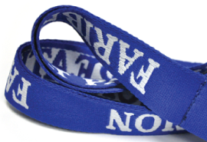 | Name tag lanyards: | $1,000
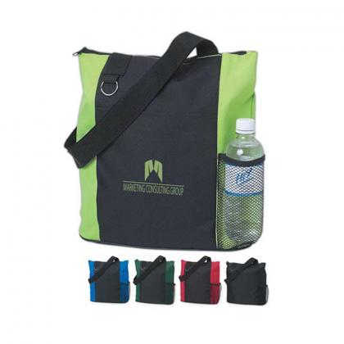 | Conference tote bag | $3,700
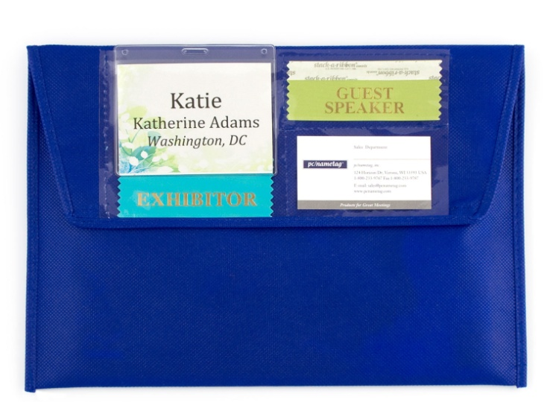 | Conference materials envelope: | $1,600

Please complete the Sponsorship & Advertising Opportunities form on page 3
and send to Tracy Schubert: tschubert@3rww.org.

Questions? Contact Tracy at 412-721-6868 or tschubert@3rww.org.

Three ways to pay:

- Make one payment by including the total cost from your Advertising & Sponsorships Form on your exhibitor registration form. (Note: Sponsorships should be confirmed by 3RWW before sending payment.)

- Make a separate check for your sponsorship and/or ad payable to 3RWW.

- Pay for your sponsorship and/or ad by credit card (3% transaction fee applies), via PayPal. (3RWW will send a PayPal invoice to you. You do not need a PayPal account to process your credit card payment.)

If you would like to become a sponsor, please complete the form on page 3 and send via e-mail to tschubert@3rww.org. For questions or if you would like to sponsor an item not shown, please contact Tracy Schubert. Please note that 3RWW will also request a black and white logo in a high-resolution format (An eps file is recommended.) for printing purposes.

Advertising & Sponsorship Opportunities Form

Please indicate your advertising and/or sponsorship preferences below and send completed form to tschubert@3rww.org.

Company Name: _________________________________ Contact Name: __________________________________

Email: ____________________________________________________ Phone: ______________________________

Advertising Space
Please choose your preferred ad below:
❒ Full page $500
❒ Half page $350
❒ Quarter page $250
❒ Business card $150
❒ Inside back cover $750
❒ Back cover $1,000

Sponsorships
❒ Partial meal/break sponsorship ($600)  Full meal/break sponsorship ($3,500)
❒ AD COMBO: I would like a full-page ad with my partial meal sponsorship for a $100 savings! ($400)
❒ Name tag lanyards ($1,000)  Conference tote bag ($3,700)  Conference materials envelope ($1,600)

(PLEASE NOTE: Sponsorships are awarded on a first-come, first served basis, so please indicate your first and second choice sponsorship preferences. For food/beverage sponsorships, please indicate the meal and date you would like to sponsor on the choice lines below. Options include: Wed, Nov. 1 – Breakfast, Lunch, or Refreshment Break or Thurs, Nov. 2 – Breakfast or Lunch.)

1st choice:_____________________________________ 2nd choice:_______________________________________

Payment:  Included with exhibitor registration payment  Check  Credit Card via PayPal

Ad cost (based on size selected): $________________
Partial Meal Sponsorship cost ($600): $________________
Partial Sponsorship/Ad Combo (add $400) $________________
Full Meal Sponsorship ($3,500): $________________
Specialty Item Sponsorship (based on item selected): $________________
Total: $________________

