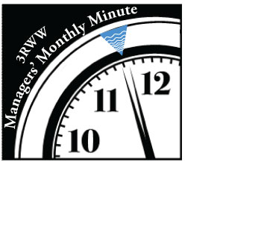**Manager’s Minute Content**

**January 2016 Update:**

**Where Does the Water Come From?**

This Manager's Minute continues the series that explores the issue of inflow and infiltration into our separate sanitary sewer system and solutions to help address these problems to more cost effectively treat wastewater.  We encourage you to share these with your elected officials and to contact 3 Rivers Wet Weather if you would like additional information.

The bar graph below compares sources of sewer flow in a number of local sewersheds for a 12-month period during the consent order flow monitoring that took place from January 2008 through April 2009.

The red portions of the graph are the total annual flow caused by groundwater infiltration into the sewer system, the blue portion is that directly caused by rainfall while the green portion is the user-generated sewage. This illustrates the need to look at repairs and improvements in separate sewer areas, such as lining, pipe bursting, or sewer line replacement.

In a future Manager’s Minute, we will discuss inflow reduction.

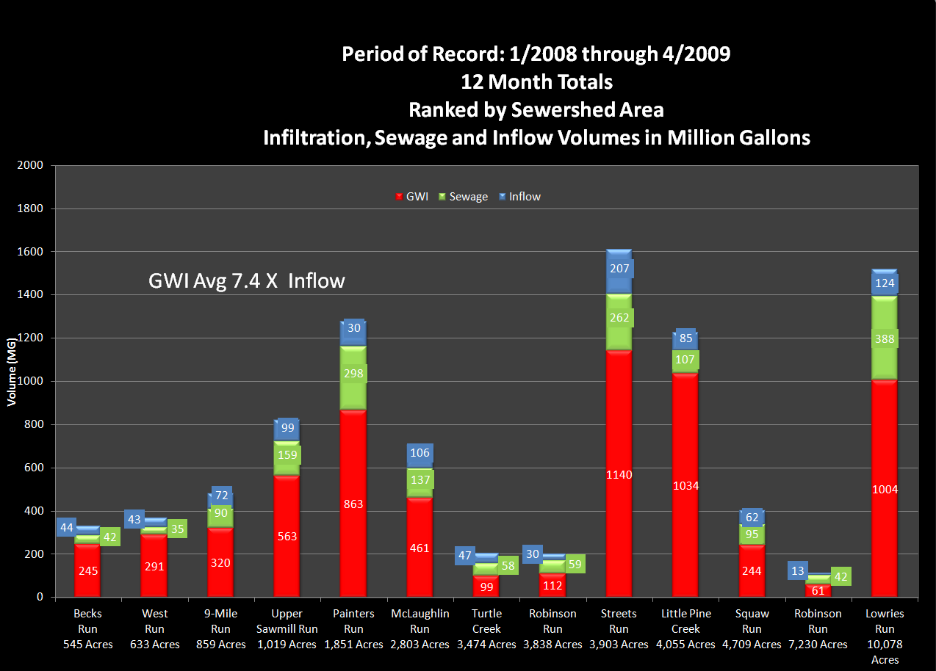

**February 2016 Update:**

On January 28, 3 Rivers Wet Weather held its first wet weather webinar—Demystifying the Stormwater Management Fee--as part of its ongoing Wet Weather Workshop Series.  Guest presenter Ruth Hocker, Stormwater Program Manager for the City of Lancaster shared the City’s experience in implementing a stormwater fee including:

• Stormwater management issues that were drivers to implement the fee

• Steps, logistics, timeline, and resources used to develop and implement the fee

• Uses and benefits of the funds to date

• Lessons learned and advice on adopting a stormwater fee.

She provided great insight and guidance for communities considering a stormwater fee.  For more information, [view the presentation or experience the entire webinar through a video recording](http://www.3riverswetweather.org/resources/wet-weather-workshops).

Our next workshop in the series—MS4 Inspections: Is Your Municipality Ready—will be held at the Green Tree Municipal Building on February 25 from 9:00-11:00 a.m. [Check out our website for more information or to register](http://www.3riverswetweather.org/ms4-inspections-your-municipality-ready).

**March 2016 Update:**

In a previous Manager’s Minute, we showed that groundwater (infiltration) comprises a much larger proportion of the flow than sewage or stormwater (inflow) in most municipal sewersheds.  The graphic below shows proportions of these three components in the 70 billion gallons of flow that travels through the ALCOSAN System in a typical year and the 9 billion gallons of overflow that exceeds the system capacity in wet weather (Source: ALCOSAN’s 2014 Chapter 94 report and “Starting at the Source” Technical Report, August 2015).

The new Phase 1 municipal consent orders require communities to conduct studies to identify the most cost-effective opportunities for source reduction in anticipation of future municipal flow targets. Green infrastructure is a tool for addressing some of the overflow volume in combined systems, but separate systems must look at the groundwater component to be most effective. The 2004 consent orders already required that separate sewer municipalities address sources of inflow so now the focus needs to be on groundwater infiltration. Flow monitoring and flow isolation studies will be needed to identify the wettest areas of your community that will benefit from green infrastructure, sewer separation or pipe lining and replacement.

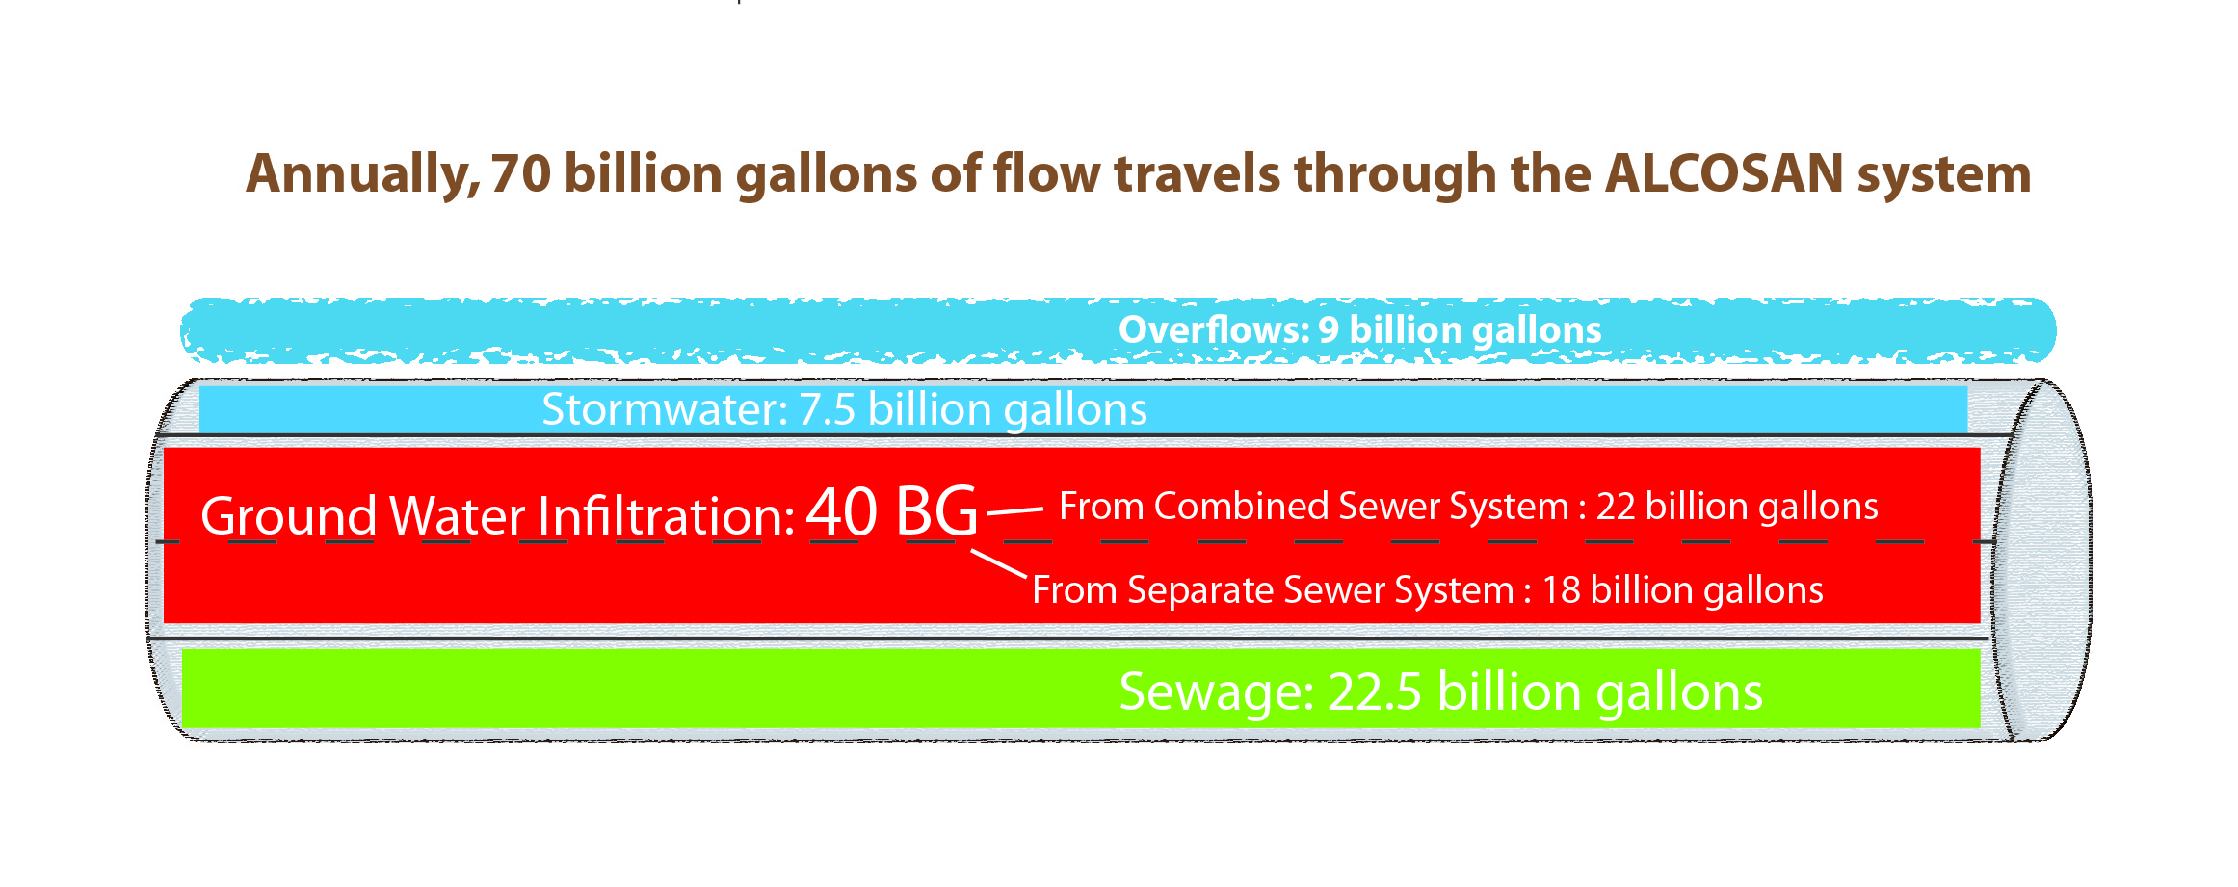

**April 2016 Update:**

3 Rivers Wet Weather would like to take this Manager’s Minute as an opportunity to thank ALCOSAN and its Board of Directors for approving 3RWW funding at their March 24 meeting. This funding will allow us to continue our support of the ALCOSAN customer municipalities on issues such as municipal consent order compliance, green infrastructure and source reduction projects, flow targets, codes and ordinances review, and integrated watershed planning. These will be critical priorities in our region’s efforts to develop and implement a long-term wet weather plan that will lead to improved water quality.

We extend our sincere gratitude to all of the communities who have shown 3RWW their steadfast support. We are committed to assisting you throughout this consent order and planning process and

we look forward to continuing our longstanding partnership with ALCOSAN, so that we may all work together toward the most cost-effective sustainable wet weather solution for our region.

**May 2016 Update:**

Municipal managers and officials play a crucial role in protecting water quality in our communities. Taking a proactive approach to stormwater management can result in long-term savings by reducing the need for costly remediation, clean up and repair. In addition, better stormwater management ensures municipal compliance with MS4 requirements; and also improves water quality for community recreation, water supply, and wildlife habitat.   Many tools are available to help you educate and engage your various audiences as required under the MS4 permits.

Here are a few links to help you get started:

* <http://www.3riverswetweather.org/resources/educational-reference-materials>

Feel free to use materials created by 3 Rivers Wet Weather (free of any copyright) in newsletters, municipal buildings, newspapers, etc.

* [http://www.dep.pa.gov/Business/Water/PointNonPointMgmt/StormwaterMgmt/Stormwater/Pages/MS4-Resources.aspx#.VyOAJ_krJ9M](http://www.dep.pa.gov/Business/Water/PointNonPointMgmt/StormwaterMgmt/Stormwater/Pages/MS4-Resources.aspx#.VyOEUfkrJ9M)

 PADEP’s Website provides a selection of resources for those seeking more information on MS4s or assistance with implementing stormwater management programs or other permit requirements. (Note that important changes to the permit are coming in 2018.) Most MS4s will be required to include a completed stormwater pollutant removal plan with their NOI/application.  Development of this plan will take time and resources. Guidance is available on the [PADEP website](http://www.dep.pa.gov/Business/Water/PointNonPointMgmt/StormwaterMgmt/Stormwater/Pages/default.aspx#.VyOB0fkrJ9M).

* <http://www.stormwaterpa.org/overview.html>

**Clean Your Water is a section of the Stormwater PA website** designed to provide the information and educational resources you need on stormwater runoff and water quality.  Several watersheds are featured where you can learn from their experience and access resource materials for use in your own community

**June 2016 Update:**

As the new Phase 1 municipal consent orders are underway, 3 Rivers Wet Weather will soon be inviting municipal engineers to participate on an ACO Technical Support Working Group. The purpose of this group will be to provide assistance to municipalities in coordinating and preparing to meet the compliance requirements of the municipal consent orders including source reduction studies and demonstration projects. Just as a quick reminder of upcoming deadlines for the consent orders:

• Dec. 1, 2016: Progress report on compliance efforts

• Aug. 1, 2017: Completion of flow reduction demonstration project

• Dec. 1, 2017: Source reduction studies due

In this month’s Manager’s Minute, we are also pleased to announce an important addition to the 3 Rivers Wet Weather staff; Mark Wolinsky. Mark will serve as 3RWW’s new Deputy Director. Previously, he served in several capacities, most recently as Assistant Manager for Hempfield Township Municipal Authority, where he worked for a total of 27 years. You will have the opportunity to meet Mark at many upcoming meetings and we look forward to putting his knowledge and experience to work to accomplish our mission of assisting municipalities in addressing our region’s wet weather issue.

**July 2016 Update:**

As you are aware, 3 Rivers Wet Weather has organized and coordinated a variety of working groups and subcommittees to assist municipalities as wet weather issues and consent orders have evolved over time. This month’s Manager’s Minute will give you a quick overview of our current and/or new committees so that municipalities can actively participate in these groups.

**Consent Order Working Group:** This is a newly formed technically focused working group that will address the compliance requirements in the Phase I municipal consent orders including siting, designing and implementing source reduction technologies and developing a standard template for the Source Reduction Study, due in December 2017.  This will also be a forum for communities to share their successes, problems, and questions related to consent order compliance.

* Members: Municipal engineers
* Meeting Frequency: Monthly

**The first meeting of the Consent Order Working Group will be July 14 at 9 a.m. at the Green Tree Municipal Building. Please notify us if your municipality will be participating in that initial meeting by emailing** [**Jgamble@3rww.org**](mailto:Jgamble@3rww.org) **with the name(s) and email address(es) of your representative(s).**

**3WG (Wet Weather Working Group):** Focuses on the wet weather planning process.

* Members: municipal managers, elected officials, ALCOSAN and other stakeholders
* Meeting frequency: As needed (every two or three months)

**Please note that the July 14 meeting has been canceled. Municipal managers will be notified when the next meeting is scheduled.**

**Source Reduction and Flow Target Subcommittee:** Subcommittee of 3WG, which focuses on

developing goals and implementation strategies to reduce groundwater infiltration and stormwater inflow and establish flow targets that are technically feasible and cost-effective.

* Members: Municipal engineers and ALCOSAN
* Meeting Frequency: Monthly (soon to be meeting twice monthly)

3 Rivers strives to fulfill its mission of helping ALCOSAN municipalities address the region’s wet weather issues. Please let us know if there are additional ways we can help your community to comply with wet weather and water quality requirements.

**August 2016 Update:**

As you may know, the Source Flow Reduction and Flow Target Subcommittee has been meeting monthly since June 2015 to develop goals, implementation strategies and flow targets to reduce groundwater infiltration and stormwater inflow.

Attached is a schedulewhich captures some of the key activities and requirements for municipalities to comply with the current municipal consent orders including a demonstration project by August 2017 and Source Reduction Study by December 2017. It also includes ALCOSAN’s responsibility to develop flow targets for each customer municipality by January 2017.  Highlighted in yellow in the attached document, you will find municipal responsibilities and opportunities to review and comment on the development of flow targets.  As municipalities develop their budgets for next year, they should consider what funding will be required for source reduction projects.

These flow targets are being developed in a collaborative process between ALCOSAN and the Source Flow Reduction and Flow Target Subcommittee, and I encourage you to review and provide comments on draft flow targets and the summary report, which will be distributed to you as they are developed.  If you have any questions, please contact me at [jschombert@3rww.org](mailto:jschombert@3rww.org) or (412) 578-8375.

You can find the municipalities represented on this committee, the mission of this group, and the schedule on the 3RWW website at [www.3riverswetweather.org/municipalities/municipal-tools](http://www.3riverswetweather.org/municipalities/municipal-tools)

**September 2016 Update:**

Important reminder: A majority of the Phase I Consent Order and Agreements (COAs) have a December 1, 2016 is the deadline for municipalities in the ALCOSAN Service Area to submit a progress report documenting compliance efforts. Please make sure to review your specific order and time frame to respond.

The report should include:

a.       A description of the actions that have been taken toward achieving compliance with the COA;

b.      A description of all activities scheduled for the remainder of the COA; and

c.       A description of any problems or delays encountered or anticipated regarding the performance of the activities required by the Consent Order and Agreement.

Also note that municipal funds may need to be allocated during your budgeting process to implement the flow reduction demonstration project(s) required by the COA (Deadline is typically August 1, 2017, but please review your COA for your specific due date.) and for the matching funds that will be required for municipalities preparing applications for the ALCOSAN GROW program.

The Feasibility Study Working Group developed a Sewer System Operating Budget template that you may find useful.  It has sample line items, including administration, legal, engineering, regulatory compliance, and system maintenance items.  You can download it from the [Municipal Tools page](http://www.3riverswetweather.org/municipalities/municipal-tools) of the 3RWW website (under the Budgets heading). If you have any questions, please don’t hesitate to contact John Schombert at 412-578-8375 or jschombert@3rww.org.

**October 2016 Update:**

The 3 Rivers Wet Weather 2016 Sewer Rate Study Update is now available online on the 3RWW website. [www.3riverswetweather.org/resources/educational-reference-materials/sewer-rate-study](http://www.3riverswetweather.org/resources/educational-reference-materials/sewer-rate-study)

3RWW provides this information so that municipalities can compare their rates to neighboring communities. ALCOSAN charges are included in the rate calculations.  These tables compare rates to median household income (MHI) allowing you to measure the current level of burden on your ratepayers.  Environmental Protection Agency guidance suggests that sewer rates in excess of two percent (2.0%) of median household income are considered a hardship. In our region, the current average rate is 1.07% of the MHI, with a low of 0.32% and a high of 3.03% (See Sewer Rate Survey Update with Median Household Income: 2016). The sewer rate study update also contains graphic comparisons of sewer rates by Eastern, North and Southern basins. We encourage you to share this sewer rate study information with your council.

**November 2016 Update:**

Mark your calendars for an important **Municipal Source Reduction and Flow Target Update** meeting for municipal managers and elected officials.

**Wed., November 30, 2016 7 p.m.**

**DoubleTree by Hilton- Green Tree**

500 Mansfield Avenue

Pittsburgh, PA 15205

The agenda will include:

• An ALCOSAN update on EPA’s information request (308 letter) regarding source reduction and flow targets.

• A progress report from a subcommittee of the 3 Rivers Wet Weather Working Group—the Source Flow Reduction and Flow Targets Subcommittee. Over the last 18 months, municipal engineers and ALCOSAN representatives serving on the subcommittee have collaborated on developing cost-effective and achievable metrics for inclusion in ALCOSAN’s 308 letter response.

• An overview on how ALCOSAN can assist municipalities in their source reduction efforts.

**RSVPs are required for this important meeting. Please follow the link below to complete a short RSVP for yourself and other municipal representatives who plan to attend.** [**Register**](http://www.3riverswetweather.org/municipalities/basin-groups/meeting-municipal-source-reduction-and-flow-target-update)

Watch your inbox for any additional updates as the event draws near.

**December 2016 Update:**

As the year draws to a close, we tend to reflect on the past—our goals, our accomplishments, our progress.  We also look to the year ahead and the change it will bring.

For 3 Rivers Wet Weather, that change will include my retirement as Executive Director of the organization since its inception in 1998.  Prior to 3RWW, I was Chief of Public Drinking Water and Waste Management Programs for the Allegheny County Health Department for 29 years.  In my nearly 50-year career in the same industry, I have enjoyed not only professional relationships, but friendships, for which I am very grateful.  I would like to convey my appreciation for your support and active involvement that have helped the region collaborate on such a challenging issue.  While we have made great strides over the last 18 years, we know there is still much work to be done.

3RWW is positioned to continue its work of assisting municipalities with the transitioning of Mark Wolinsky to Executive Director.  Mark, formerly Assistant Manager of Hempfield Township Municipal Authority, joined 3 Rivers earlier this year as Deputy Director.  He brings a wealth of knowledge and experience along with an enthusiasm for tackling this important issue.

Although I will officially retire from my position on December 31, I plan to continue my involvement in wet weather issues both through continued support to 3RWW, and through my role as Chairman of the Coraopolis Water and Sewer Authority and the Riverview Sanitary Authority.  I ask that you continue to support Mark and the entire staff of 3 Rivers Wet Weather, all of whom are dedicated to helping municipalities continue the momentum toward a long-term regional solution.